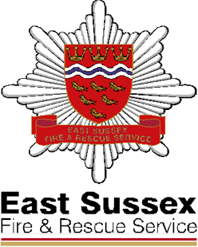

# East Sussex Fire & Rescue Service

Lewes Community Fire Station

North Street

Lewes, East Sussex

BN7 2PE

Tel: 01323 462989

Switchboard: 0303 999 1000

Fax: 01273 694169

E-mail: cpdresponse@esfrs.org

Web: www.esfrs.org

**In the case of emergency please dial 999**

Dear Resident,

**Free Smoke Alarms**

East Sussex Fire & Rescue Service are visiting your area and offering free Home Safety visits fitting Smoke Alarms if required, **all free of charge!**

**Lewes Community Fire Station**would like to visit you in your home, to provide home fire safety advice, which is specific to you, including summer/winter fire safety, BBQ and cooking, water safety when being near to rivers and lakes local to you. As well as road safety and how to protect yourself and your home from fire.

If needed, we will supply and fit a smoke alarm, **free of charge**! If you would like to take us up on this **free** offer, please contact

* **The Crew via telephone 01323 462989**
* **Or email the Station Administrators via email** [West.Group@esfrs.org](mailto:West.Group@esfrs.org)

**Please email or leave a message stating your name, address, postcode, telephone number and quote ‘Lewes Crews”.**

We look forward to hearing from you soon.

Yours sincerely

**Lewes Community Fire Station**