PE Funding

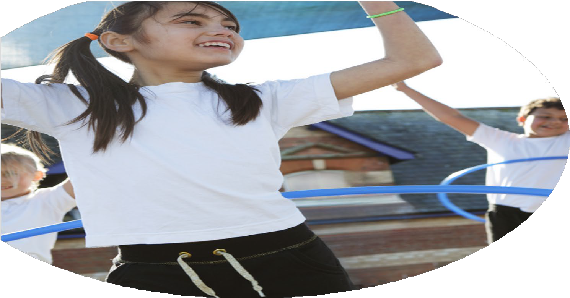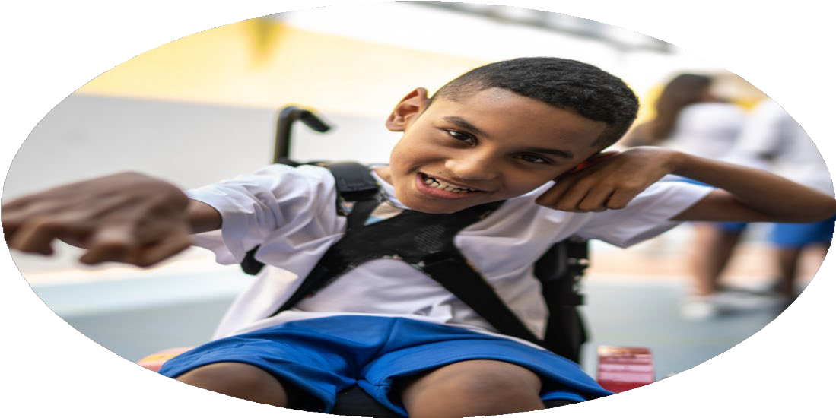

Evaluation Form

**Commissioned by**

**Created by**

Images courtesy of Youth Sport Trust

**PE Funding Evaluation Form**

 It is intended that this template should be used as preparation for the completion of the statutory digital reporting tool being introduced this academic year. You can upload data (including swimming) from this template onto this platform once it becomes accessible.

 Before you decide how you are going to use the funding for this academic year you should reflect and evaluate the impact of your use of the funding in 2023/24.

 All spending of the funding must conform with the terms outlined in the Conditions of Grant document.  The template is a working document that you can amend/update during the year.

 Based on your evaluation of last year’s funding you should decide what you intend to do this academic year, how you will do it, and what impact you expect it to have.

It is important that the funding is used effectively and based on your school’s needs.

 You must use the funding to make additional and sustainable improvements to the PE and sport in your school.  You must develop and add to the PESSPA activities that your school already offers.

*Summative digital reporting from June 2025 will continue to include swimming and water safety information therefore funding can be used to provide top-up lessons where necessary to ensure pupils meet national curriculum swimming requirements.*

**We recommend that you start by reflecting on the impact of current provision and reviewing your previous spend**

|  |  |  |  |
| --- | --- | --- | --- |
| What went well? | How do you know? | What didn’t go well? | How do you know? |
| CPD Dance lessons for specific year groups.  Use of Southdowns Club for joint organising of fixtures throughout local area.  Design and installation of trim trail as joint project with Southover CE Primary School.  Increasing range of resources available for children to use in each playground.  Ensuring swimming lessons are available for all pupils Years 3 – 6.  Forest School implemented for whole school. | Staff voice reported increase in confidence in teaching dance techniques and lessons.  Pupils were able to attend a number of local sporting fixtures, for example football, cross-country and District Sports.  All children are able to use the trim trail on field days to increase their play experience and risk-taking.  All children have a wide range of equipment available to use to increase their imaginative play and risk-taking (see Pupil Voice, July 2024).  All children able to access swimming at Wave Leisure with 90% Year 6 able to swim at least 25m.  Pupil Voice (July 2024) and Parent Forum feedback. | Expand availability of CPD for dance and gymnastics.  Freeing up staffing for fixtures.  Continue to develop teaching children how to use playground equipment to enrich play. | Staff voice to PE lead.  Liaising with staff re cover and time taken to run fixtures.  Discussions with staff on duty, followed up with children. |

|  |  |
| --- | --- |
| What are your plans for 2024/25? | How are you going to action and achieve these plans? |
| Intent | Implementation |
| All staff will further develop CPD opportunities for staff with gymnastics lessons.  All children will have access to high quality Forest School provision to enrich their learning.  All children will have access to active brain breaks to support their learning stamina and behaviours.  All children will be able to swim at least 25m by the end of Year 6.  Children will participate in a range of local fixtures. | Hire specialist teacher to lead lessons with staff observing and discussing with specialist provider.  Timetabled sessions for each class to spend time in Forest School area and expand to EYFS Muddy Monday sessions.  Subscribe to Jump Start Johnny for all staff to access to use for brain breaks for classes as needed.  All children in Years 3 – 6 to have 2 term blocks of swimming lessons at Wave Leisure, lead by qualified swimming instructors. Children with SEND/anxiety will be supported to try getting into the water and developing their skills and appropriate.  Buy into service with Southdowns Club to organise local fixtures. Facilitate a range of children attending local fixtures. |

|  |  |
| --- | --- |
| What impact/intended impact/sustainability are you  expecting? | How will you know? What **evidence** do you have or  expect to have? |
| Improved CPD for all teaching staff in gymnastics.  All pupils will participate in Forest School blocks to enrich their learning.  Subscribe to Jump Start Johnny for all staff to access to use for brain breaks for classes as needed.  All children in Years 3 – 6 to have 2 term blocks of swimming lessons at Wave Leisure, lead by qualified swimming instructors. Children with SEND/anxiety will be supported to try getting into the water and developing their skills and appropriate.  Buy into service with Southdowns Club to organise local fixtures. Facilitate a range of children attending local fixtures. | Learning walks, Staff and Pupil Voice.  Pupil Voice will give feedback on the sessions.  All children will have access to brain breaks as appropriate, Pupil Voice feedback.  By the end of Year 6, all children will be able to swim at least 25m independently – observations.  Monitor range of uptake of attending fixtures, Pupil Voice feedback. |

|  |  |
| --- | --- |
| What **impact/sustainability** have you seen? | What **evidence** do you have? |
|  |  |