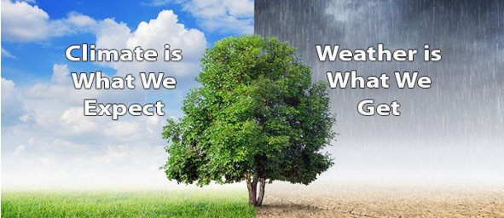

Extreme Weather

**How does what’s outside impact on our lives now and in the future?**

|  |
| --- |
| **Key concepts:** |
| bbc weather symbols 2005In a weather forecast, symbols are used to show what the weather will be like in a particular area. People check the weather forecast before they make plans for a day out.  Here are some tools to measure different types of weather:    The impacts of some extreme weathers might have devastating effects on people’s lives. For example hurricanes and floods. Extreme weather can affect our surroundings as well as our lives. |

Things to try at home:

|  |
| --- |
| **Language of a Geographer** |

|  |  |
| --- | --- |
| Weather | The day-to-day conditions of the atmosphere. Weather can change quickly. One day it can be dry and the next it may rain. |
| Climate | Average weather conditions over longer periods and over larger areas. It would take a long time for the typical climate of an area to change. |
| Temperature | How hot or cold something is, measured in Celsius or Fahrenheit. |
| Weather Forecast | A prediction of what the weather will be like in the future. This is done by looking at weather patterns. |
| Meteorologist | A scientist who observes, studies or forecasts the weather |
| Seasons | The year is divided into four seasons; spring, summer, autumn and winter. |
| Observations | What you notice when you look carefully at something |
| Record | Keeping information about something that has happened such as a measure of how much rain has fallen. |
| Extreme | Beyond what is expected as normal |
| Drought | When there is little or no rain over a long period of time. |
| Flooding | When usually dry land is covered with a large amount of water. |
| Blizzard | A very heavy snowstorm with high winds. |
| Heatwave | Unusually hot weather over a long period. |
| Hurricane | A storm with extremely high winds. |
| Polar | Weather relating to the North and South pole (polar regions) |
| Tropical climate | Very hot and humid |
| Mediterranean | A type of climate which is characterised by dry summers and mild, wet winters. |
| Mountains | The temperature on mountains becomes colder the higher the altitude. |

|  |
| --- |
| **Key questions to ask yourself:** |
| * What can we use to measure the weather? * How can extreme weathers impact on our lives? * What is the impact of the changing climate on our world? * What causes extreme weather? * What weather is considered to be extreme? |
| **Examples of extreme weather:** |
|  |

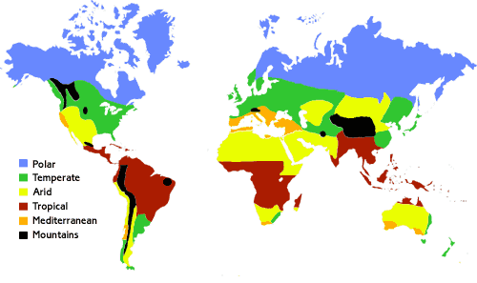

Each area of the world has its own climate. You can see on this map the different climate types.

What is the climate type in the UK?

* Make your own weather station to record the weather at home.
* Keep a weather journal, recording what the weather is like each day.
* Create a poem inspired by weather or a storm
* Research a famous storm and create an information poster.
* Create a tornado in a bottle
* Compare our climate to the climate of a country of your choice.