**The English as an Additional Language Service**

**Parent/Carer Newsletter Winter 2024**

Dear parents and carers,

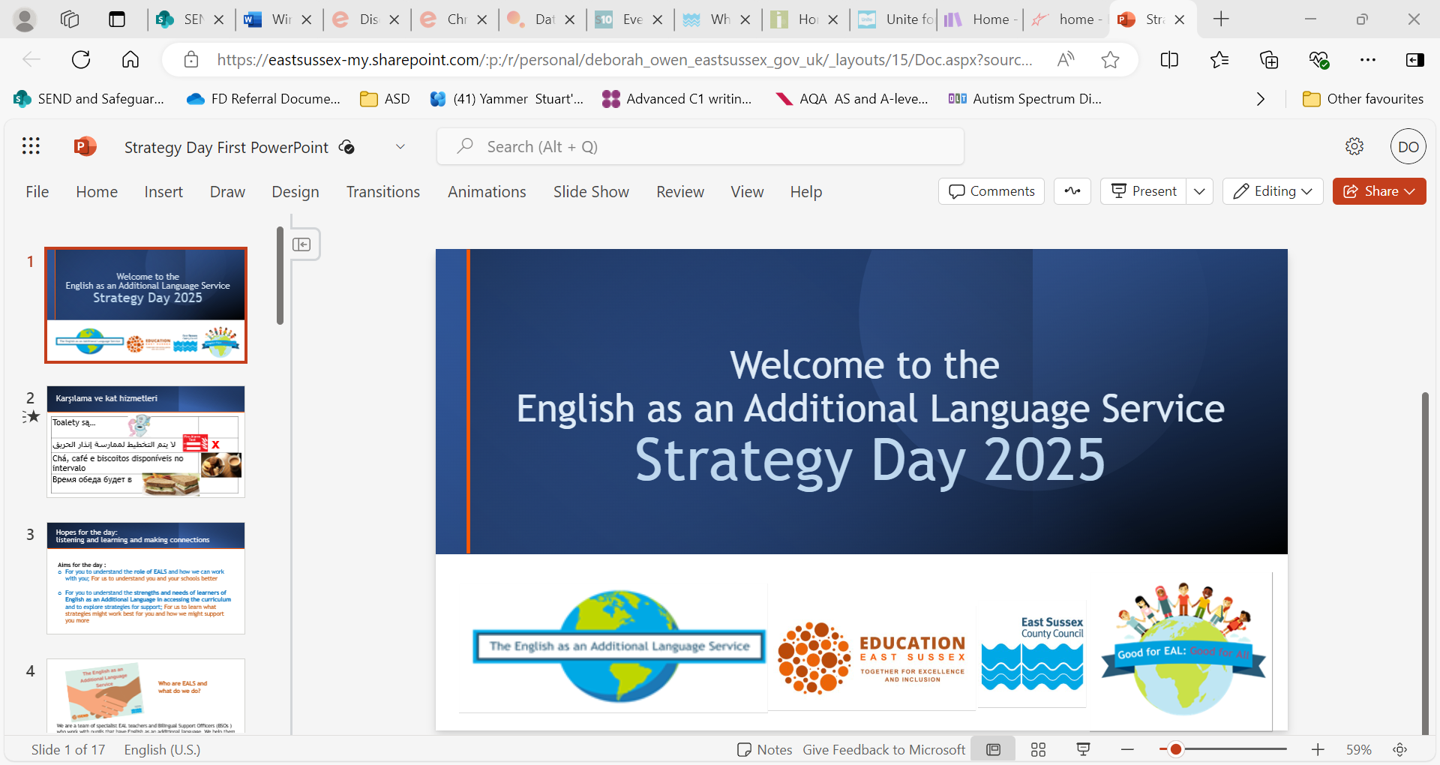

**It has been great to work with your children this school year. We hope they are all settling well into their new schools, or school years. The EAL teachers and Bilingual Support Officers all wish you a good Xmas and New Year, whether you are celebrating Christmas or not. We hope you all enjoy the break from school.**

**Are you interested in improving your English?**

There is a self-referral form here

[English Learning Pathway | East Sussex County Council](https://www.eastsussex.gov.uk/libraries/adult-learning/english-learning-pathway#:~:text=The%20English%20Learning%20Pathway%20is,charge%20across%20East%20Sussex%20Libraries.)

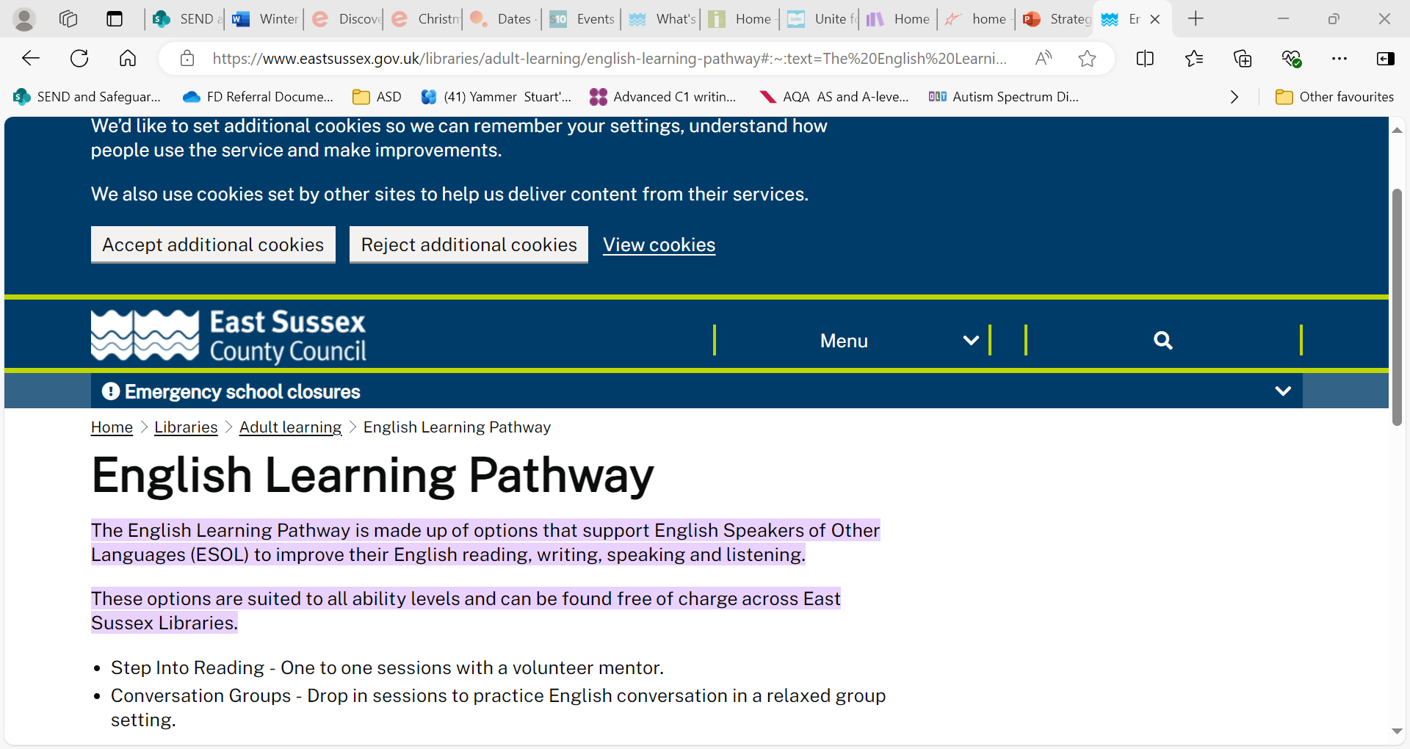

**This website has a lot of information about services in East Sussex**

[Home | ESCIS](https://www.escis.org.uk/)

There is information about community groups, learning English and much more There are pages with advice about asylum and immigration.

[Refugees, Migrant Communities and BME Archives | ESCIS](https://www.escis.org.uk/category/refugees-migrant-communities-and-bme/)

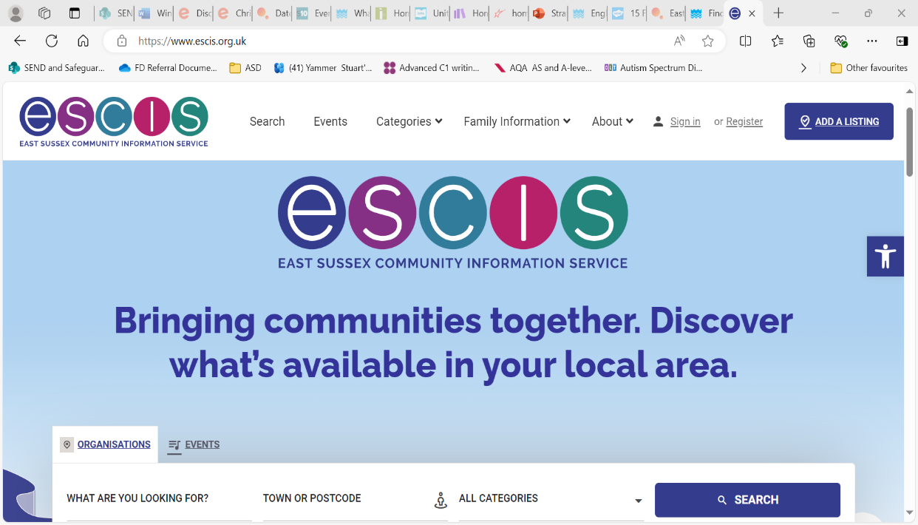

**Here are some of our favourite websites for learning – for younger and older children**

[Unite for Literacy](https://www.uniteforliteracy.com/)

[Home | LearnEnglish Kids](https://learnenglishkids.britishcouncil.org/)

[British Council LearnEnglish Teens | Free resources for teens to help improve your English](https://learnenglishteens.britishcouncil.org/)

[Home - BBC Bitesize](https://www.bbc.co.uk/bitesize)

If you are looking for free family activities for the school holiday, here are some ideas.

|  |  |  |
| --- | --- | --- |
| [15 Free Things to Do This Christmas - Twinkl](https://www.twinkl.co.uk/blog/15-free-things-to-do-this-christmas) – including winter walk ideas and things to make at home.  15 Free Things to Do This Christmas - Twinkl and 13 more pages - School - Microsoft​ Edge | Activities free for children who receive Free School Meals  [Welcome to Holiday food and fun | East Sussex County Council](https://www.eastsussex.gov.uk/children-families/childcare/welcome-to-holiday-food-and-fun)  [Eequ · After school. In place of school. Beyond school.](https://eequ.org/escchaf)  [Christmas Activities | Monday | Hastings Borough Council](https://www.hastings.gov.uk/sport_play/getactive/activehastings_listings/hastingschristmasactivitiesandfood/) | Eequ · After school. In place of school. Beyond school. and 2 more pages - School - Microsoft​ Edge |

Join your local library and borrow books free and check out the great events in the holidays and all year.

[Events | East Sussex Libraries](https://eastsussex.spydus.co.uk/cgi-bin/spydus.exe/MSGTRN/WPAC/EVENTS?HOMEPRMS=EVSESPARAMS)

Find you local library [Find a library near me in East Sussex | East Sussex County Council](https://www.eastsussex.gov.uk/libraries/local/locations)

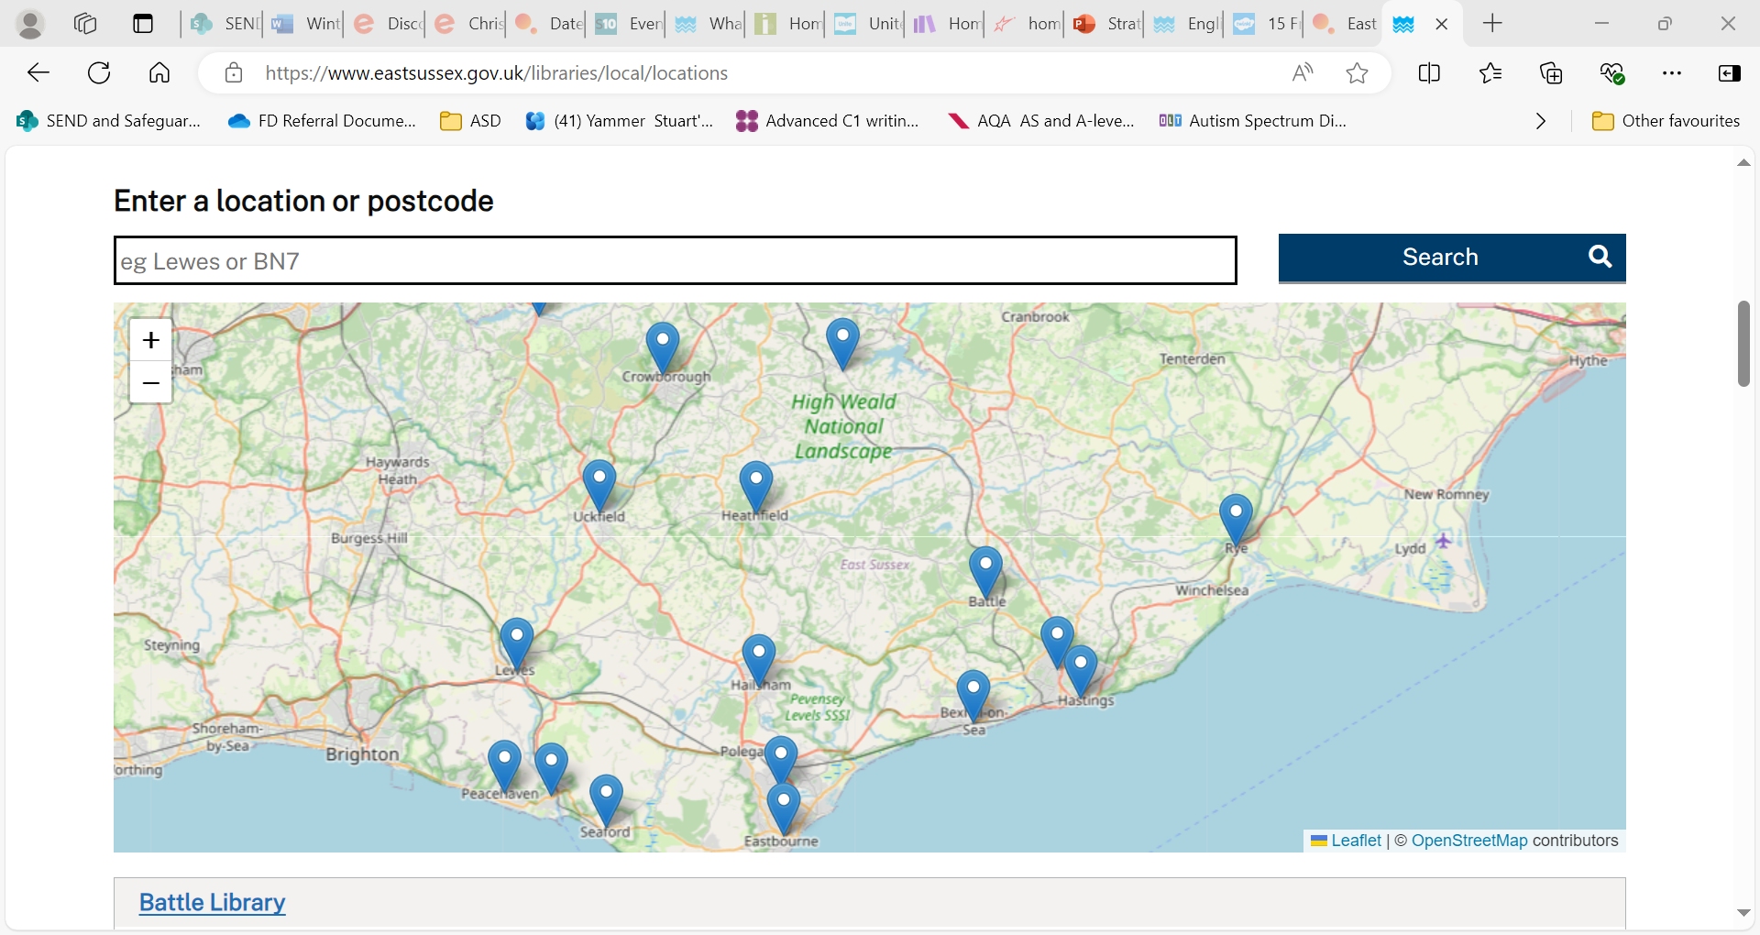

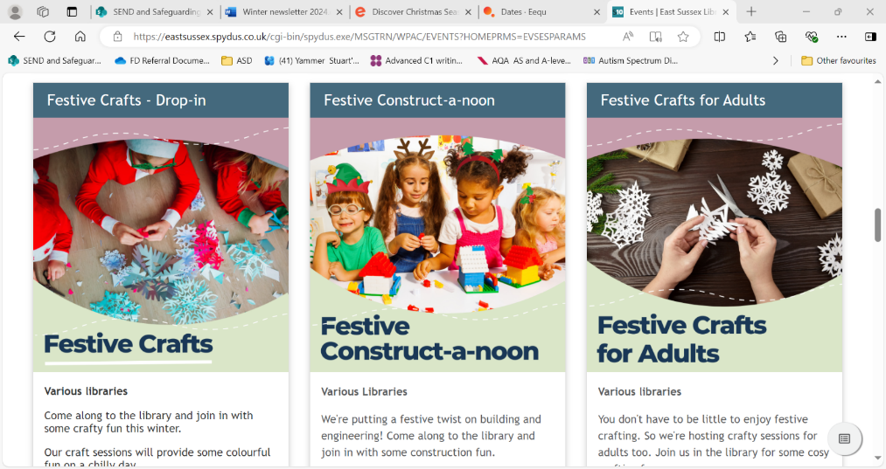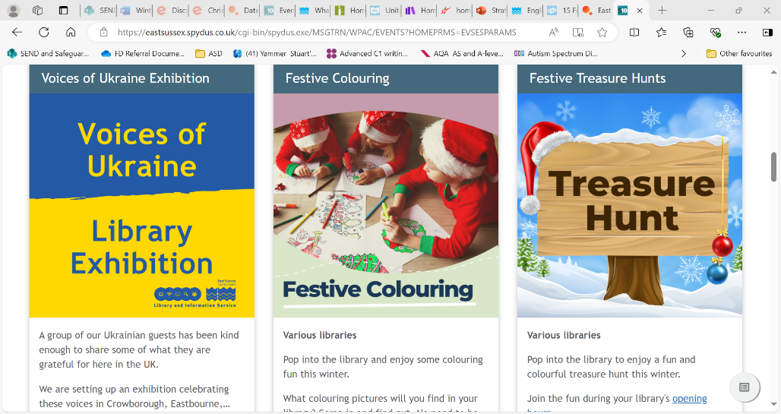

[Brighton Table Tennis Club](https://brightontabletennisclub.com/) – if you’re interested in table tennis this is a great, friendly club. Next door to the club there’s a community café with delicious, healthy food. It is pay-what-you-can.

[Welcome - Fitzherbert Community Hub](https://fitzherbertcommunityhub.org.uk/)

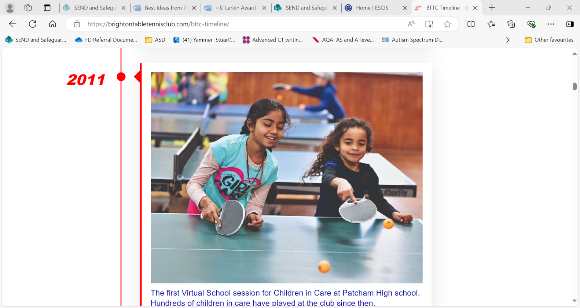 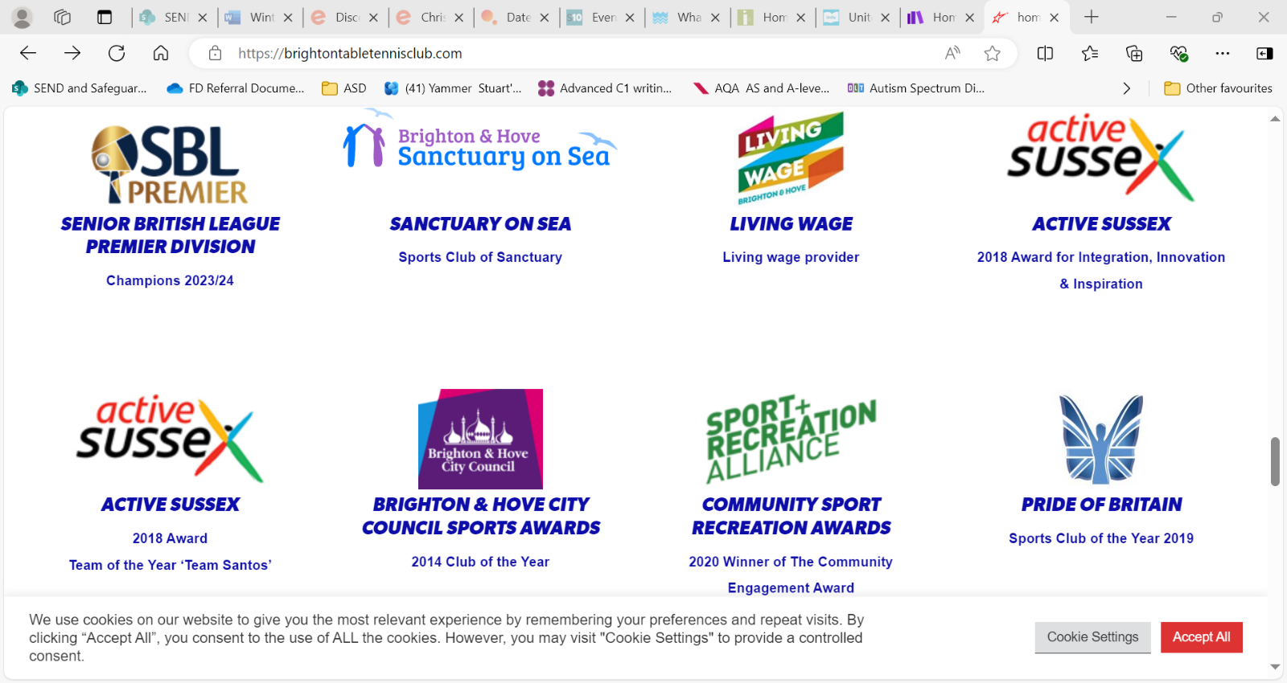

**A truly inclusive club and café!**

**And finally, this is how we want our EAL pupils to feel!**

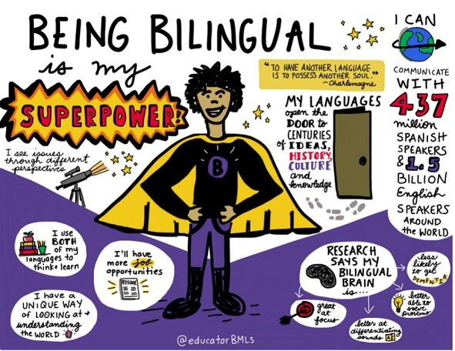

We look forward to lots of your children entering the **Val Larkin dual-language writing award** – launching in February which is **EALS Celebrate your Home Language Month.**

**Contact your EAL teacher or BSO or email** [**bilingual.support@eastsussex.gov.uk**](mailto:bilingual.support@eastsussex.gov.uk) **for an entry pack.**